All the SonarQube server configurations will be stored in SonarQube “conf” directory.

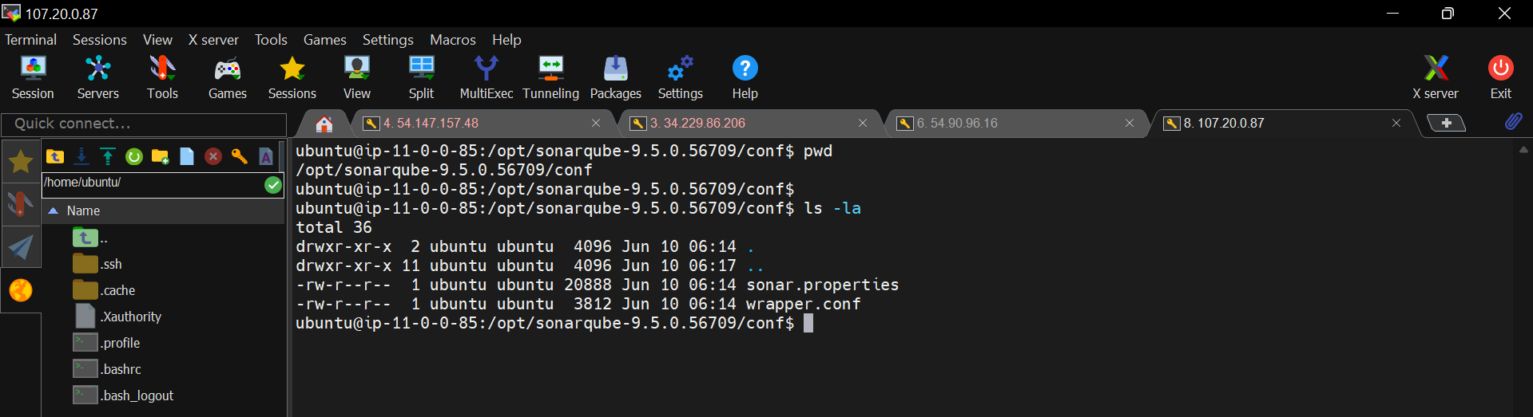

**1. How to specify the JAVA path?**

* Sudo nano wrapper.conf

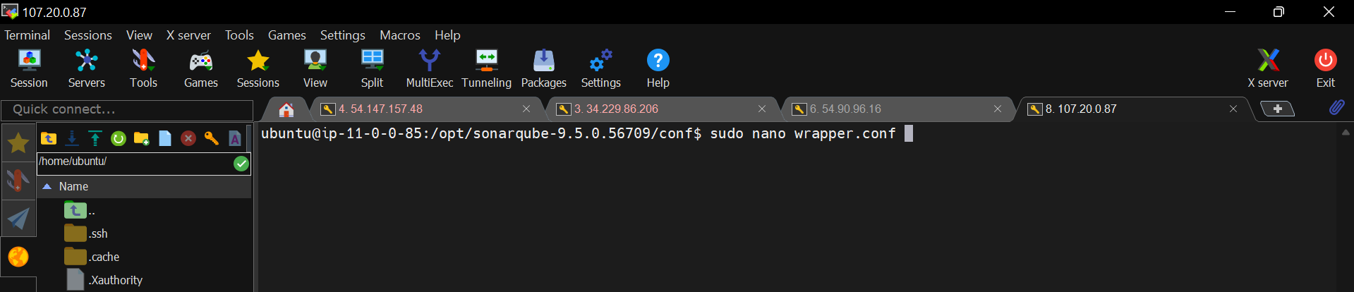

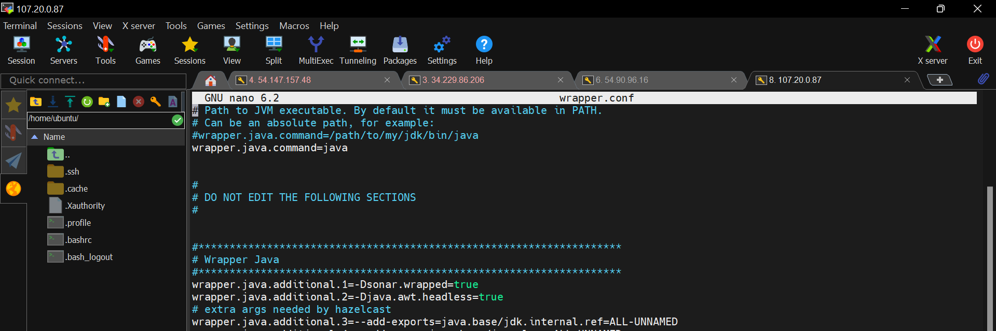

Change the “wrapper.java.command” line value from java to path of your java compiler.

How to check the java path

* cd /usr/lib/jvm/

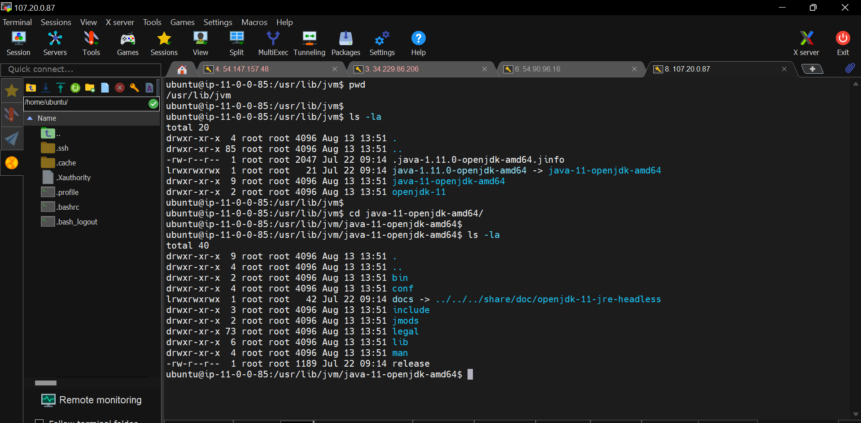

* cd bin

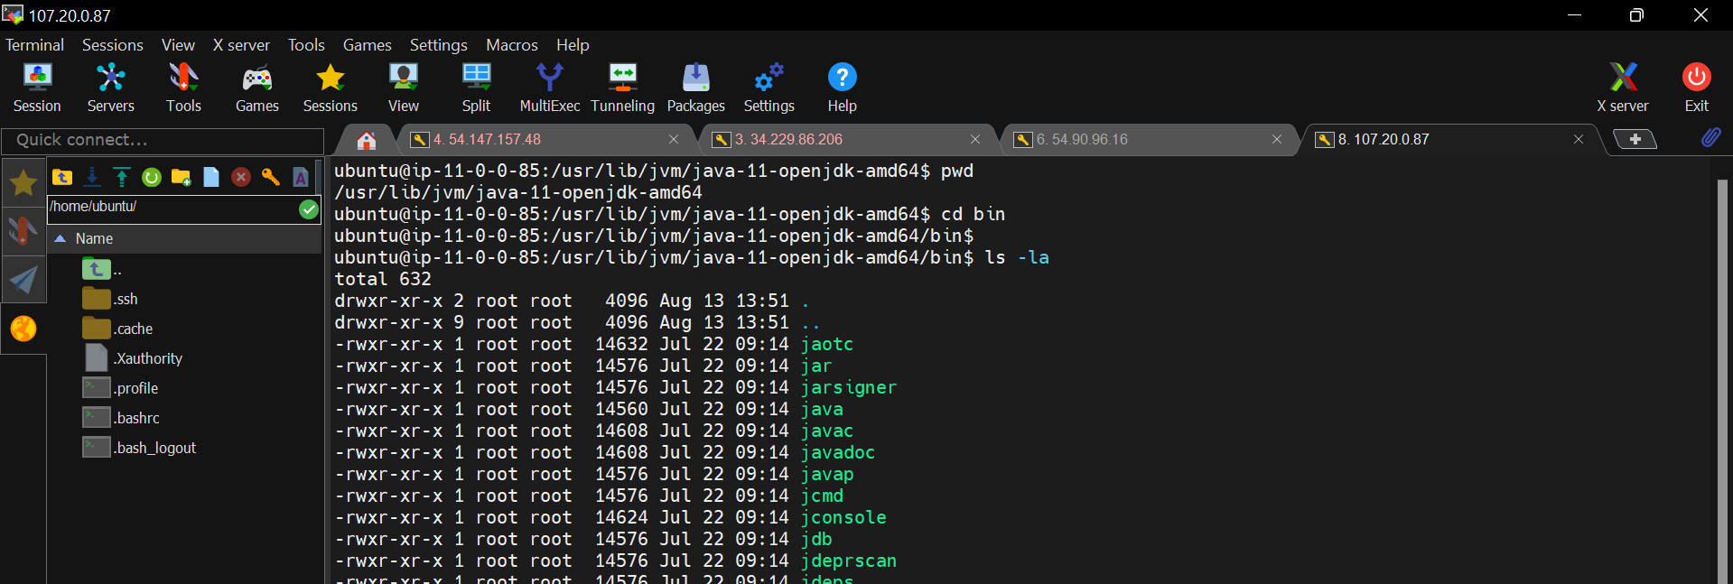

Copy this path before to the bin directory

I,e. “/usr/lib/jvm/java-11-openjdk-amd64”

Paste this path in the above file.

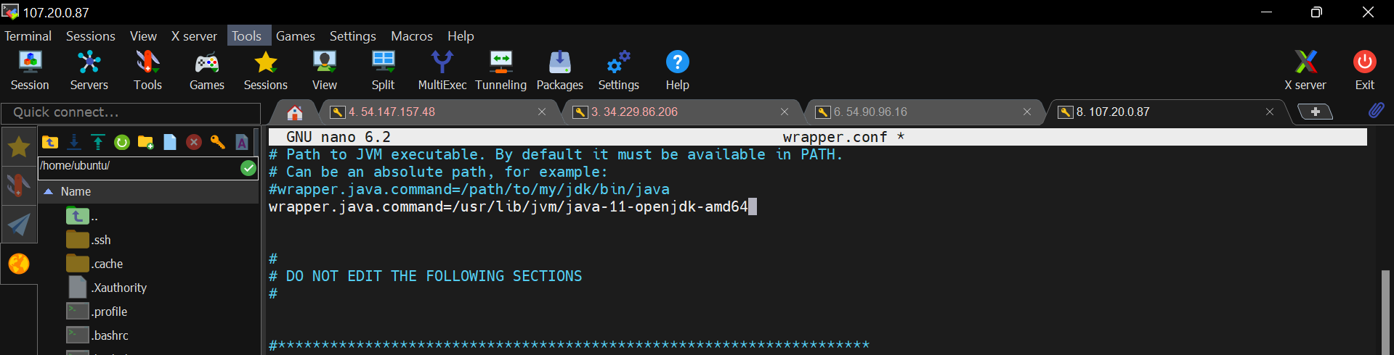

Save the file

Now, stop and start the SonarQube server to apply the latest changed configurations.

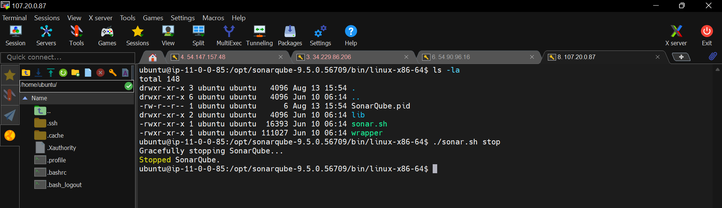

It was failed to start the server, let’s analysis the cause by checking the logs

* /opt/sonarqube-9.5.0.56709/logs

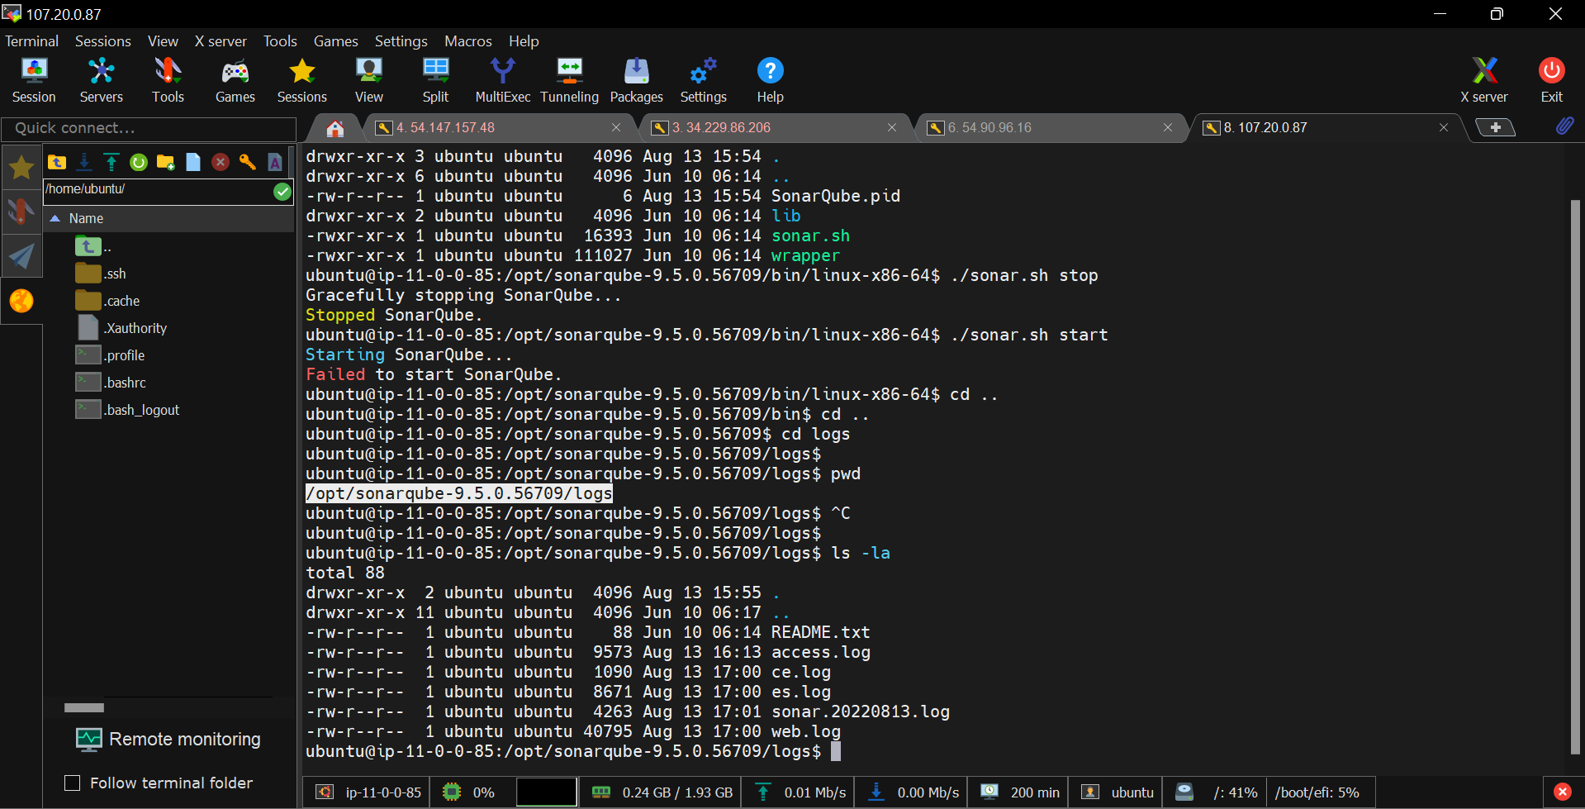

Read this log file

Jvm is failed to start.

This is because we must give the java path till the bin folder in the above edited configuration file called “wrapper.conf”

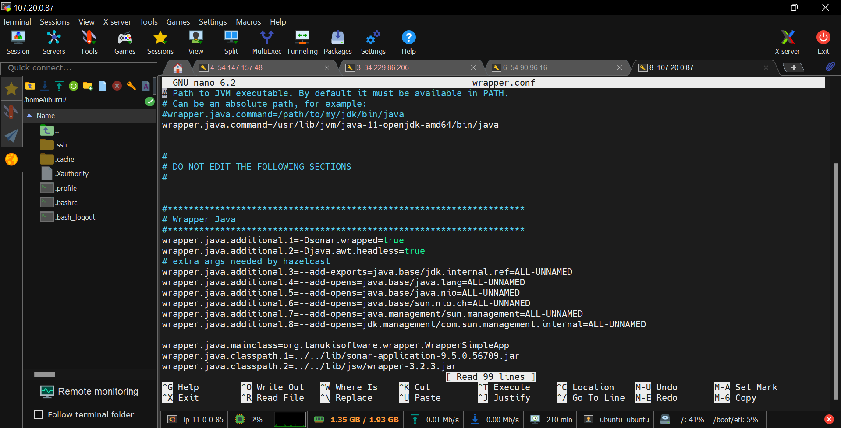

Save the file and restart the SonarQube server.

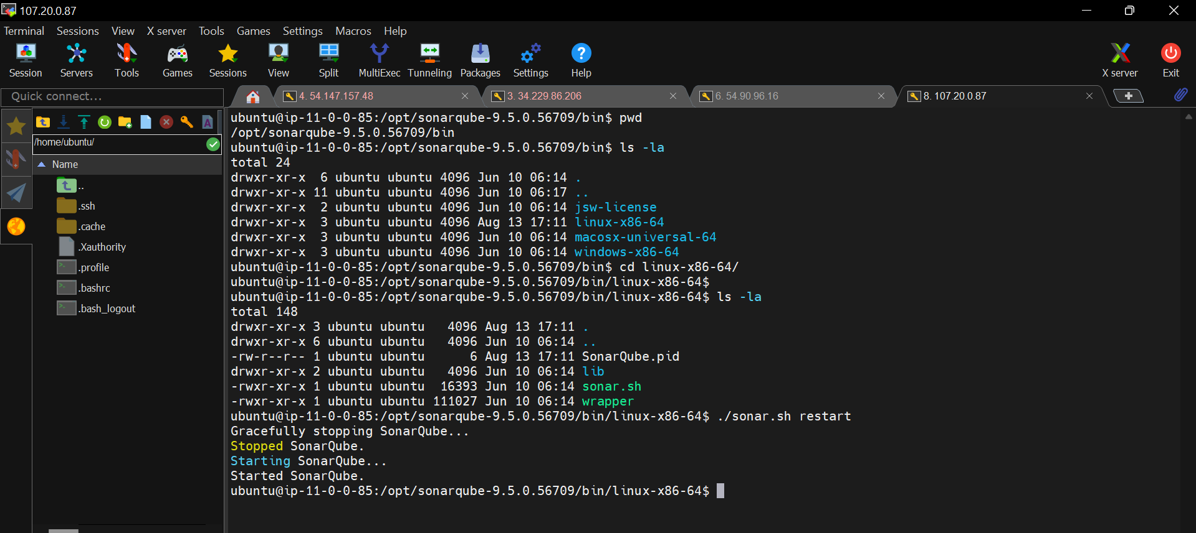

**2. How to change the SonarQube server port number?**

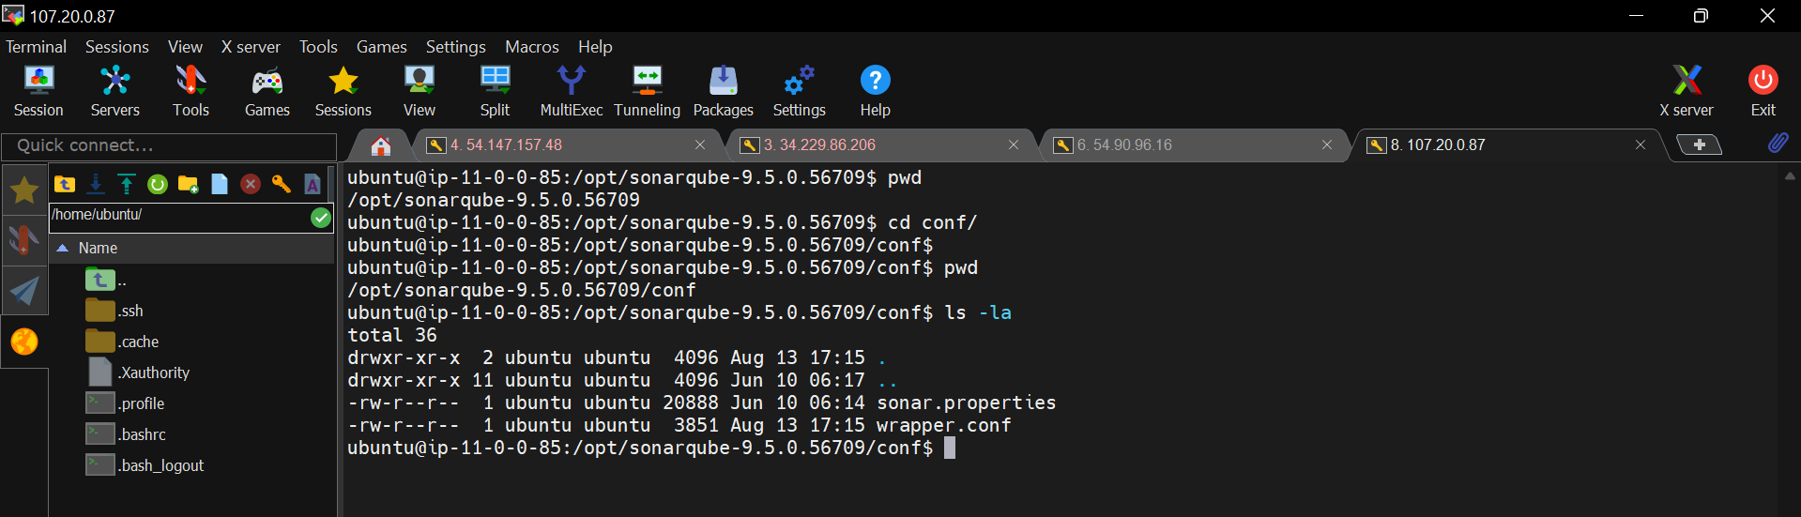

Open the “sonar.properties” file in nano/vi editor

* sudo nano sonar.properties

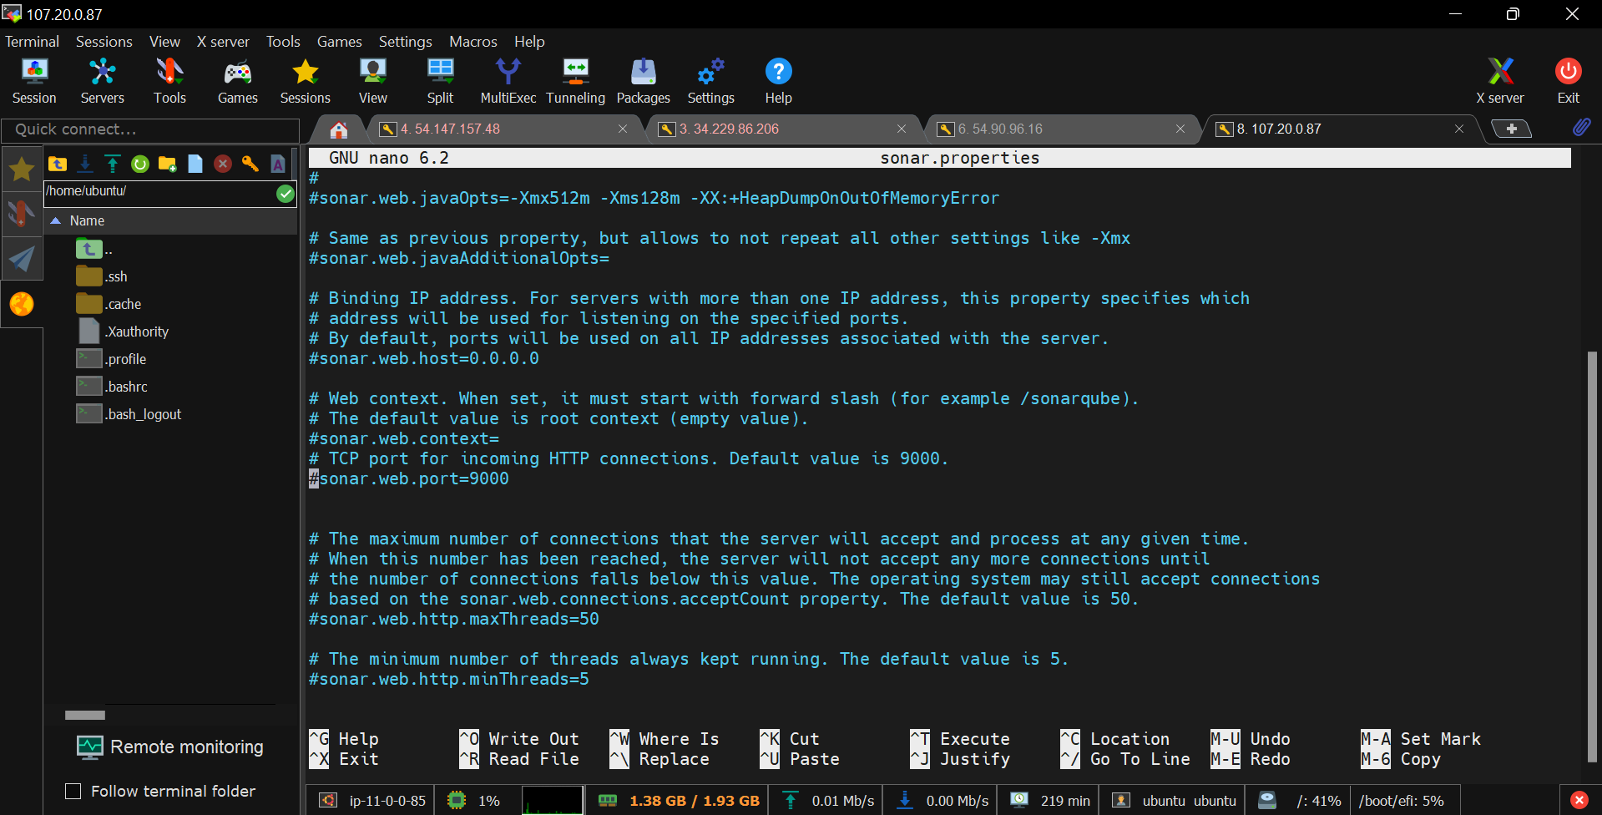

Uncomment this line and change the default port number.

But, not I am not going to change the number I will just uncomment this line and save the file.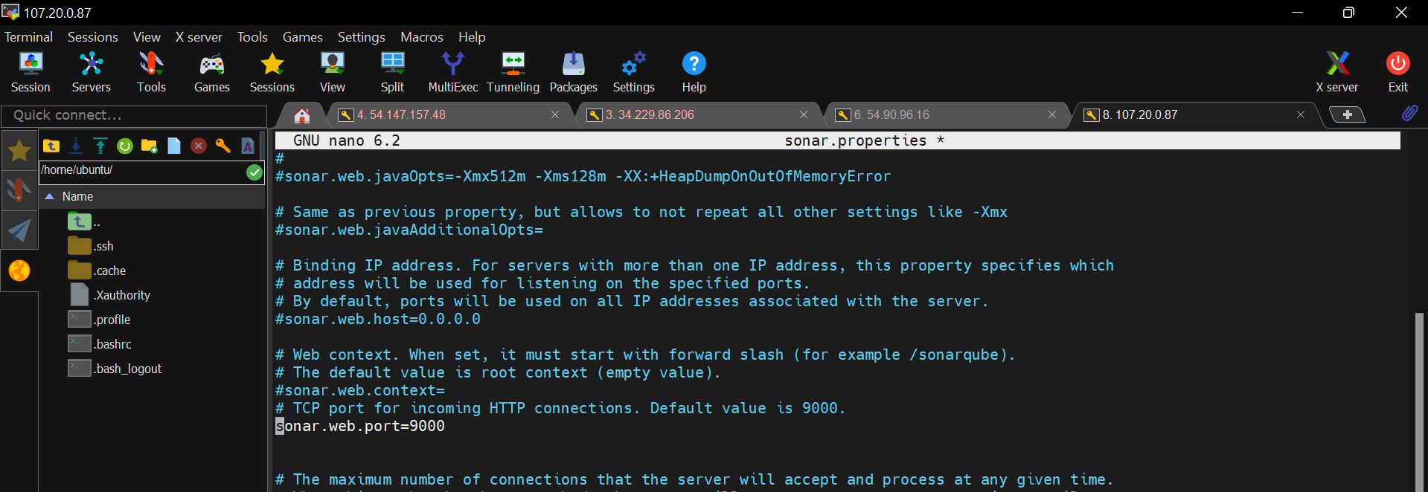

Save 🡺 ctl+s

Exit 🡺 ctl+x

To reflect any change in the configurations we need to restart the server once we are done with the changes.



**Database settings in SonarQube**

* sudo nano sonar.properties

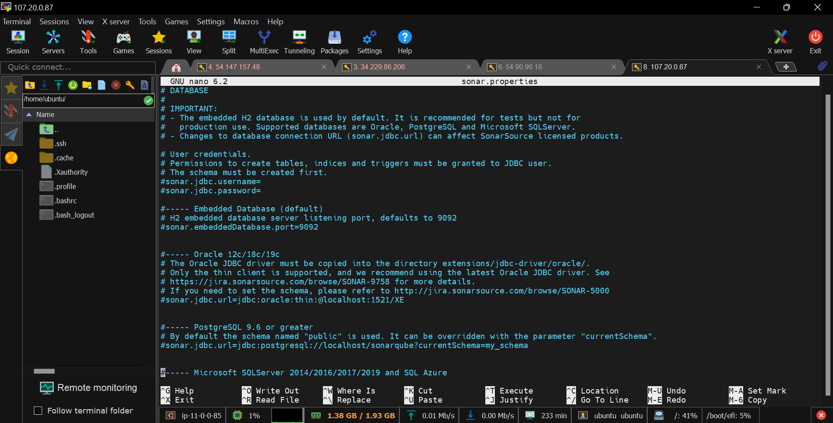

Here, we will un-comment these lines to specify the database settings like

Which database to connect 🡺 sonar.jdbc.url = <database-url>

Database username 🡺 sonar.jdbc.username = <username>

Database password 🡺 sonar.jdbc.password = <password>

As of now I am not doing any changes related to database.

Close the file. 🡺 ctl+x

**SonarQube data directories path**

* sudo nano sonar.properties

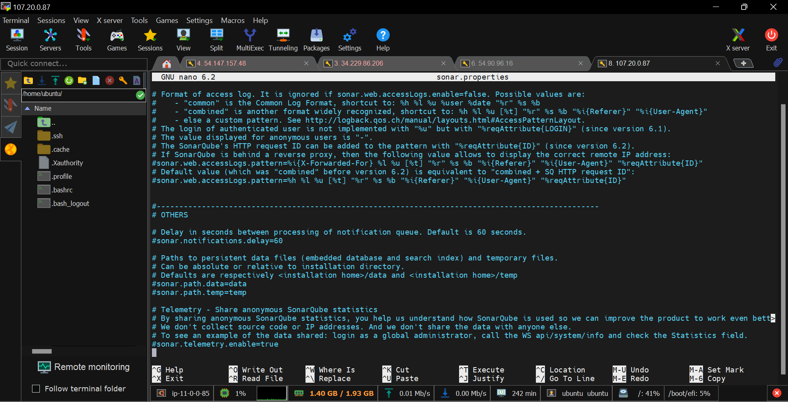

Un-comment this line and give the path where you want to store the data.

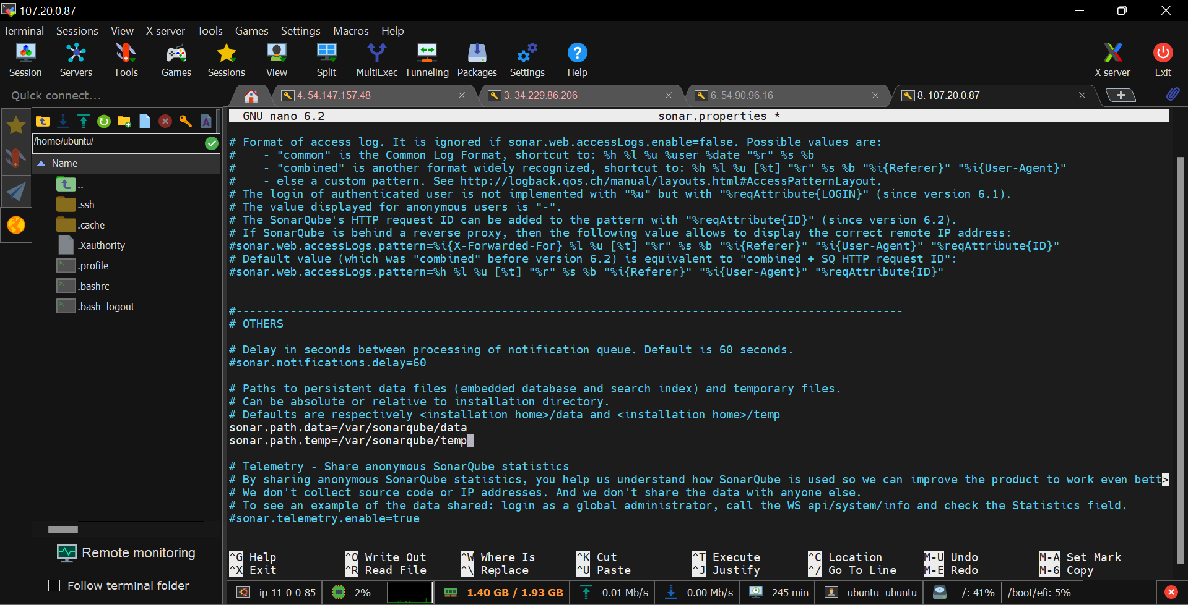

Save the file and restart the server to reflect the changes.

* cd /opt/sonarqube-directory/bin/linux-binaries-dir/
* ./sonar.sh restart

Now, refresh the browser.

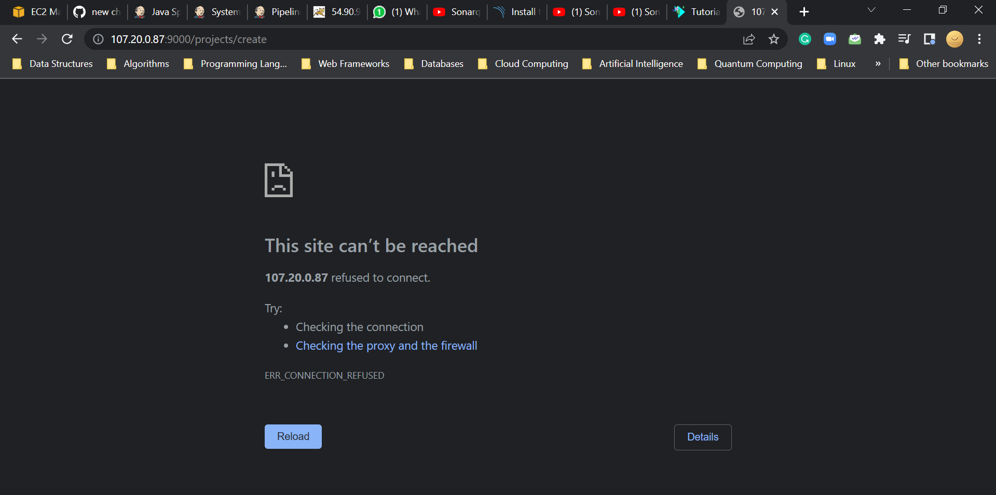

If you are getting this problem, check the logs once.

* cd /opt/sonarqube-9.5.0.56709/logs

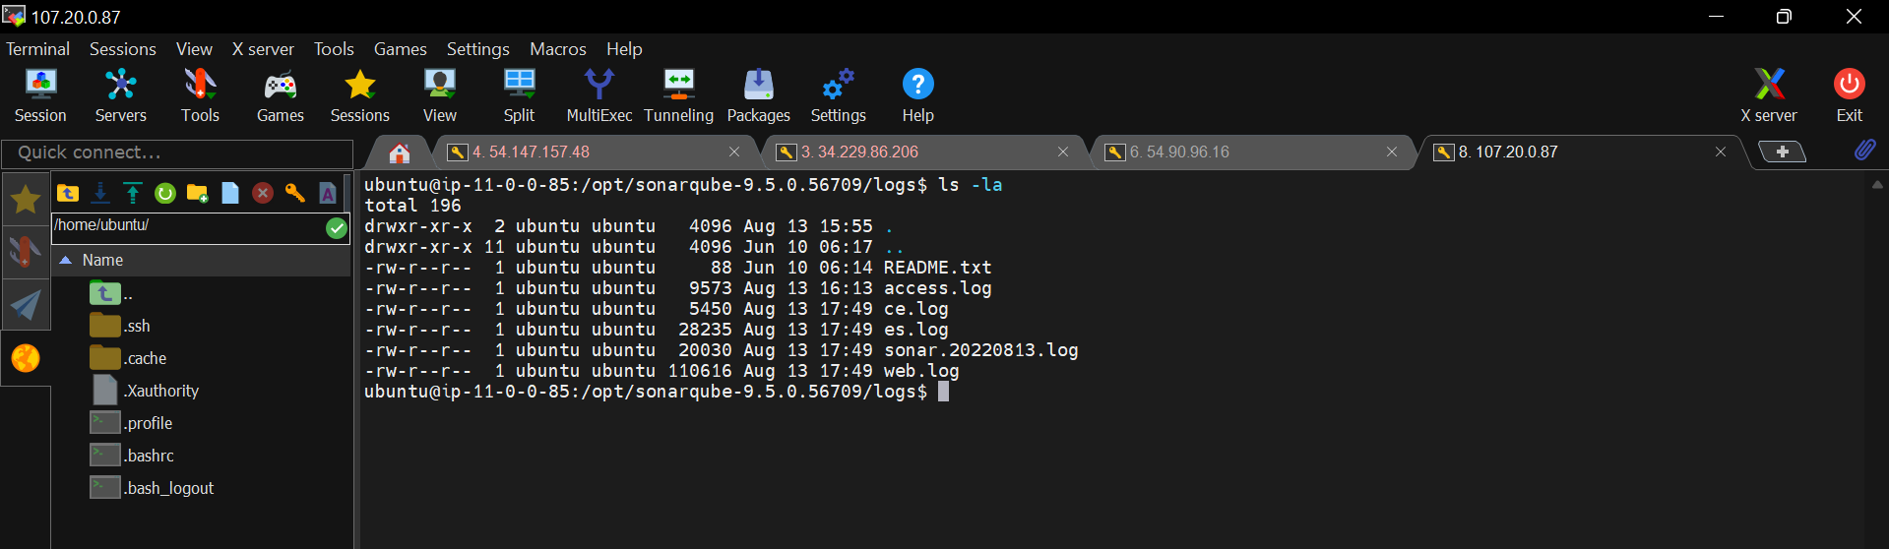

Read the above SonarQube log file

* cat sonar.<number>.log

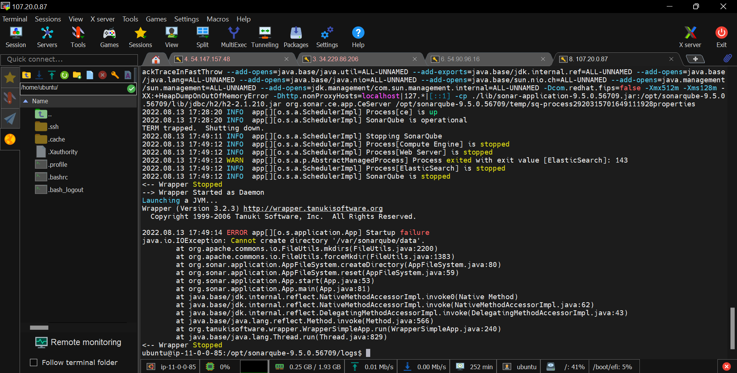

It’s failing because of not able to create the directories specified in “sonar.properties” file.

Let’s create the “data”, “temp” directories manually.

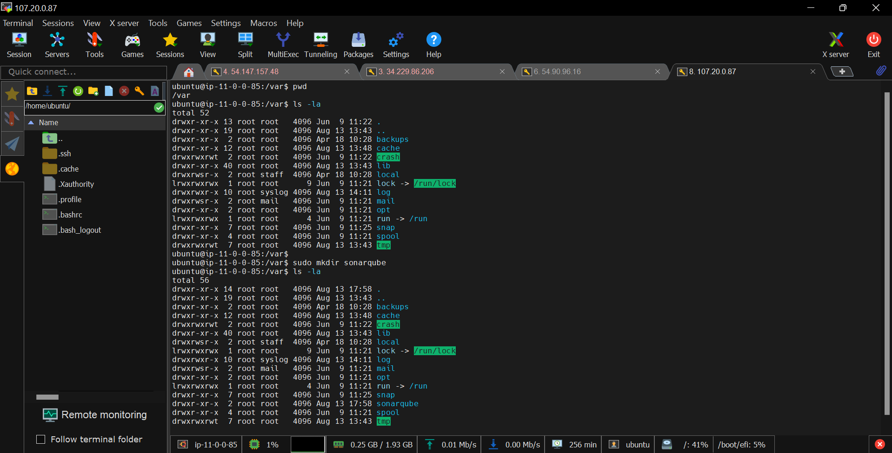

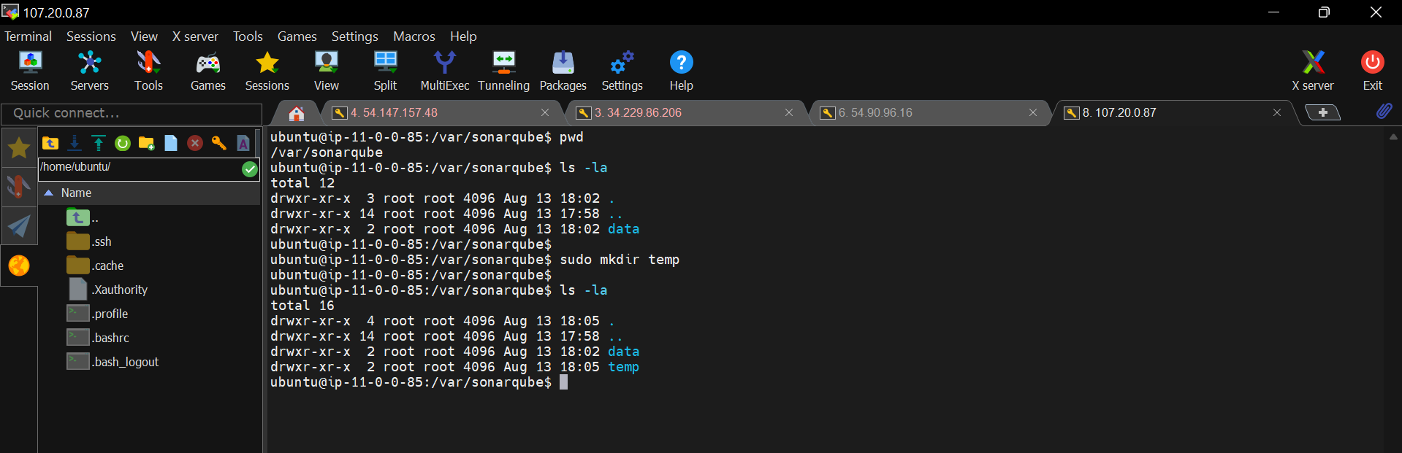

So, now we created the directories manually.

Now, we have to change the owner ship of these directories from root user to ubuntu user.

* cd /var
* Sudo chown -R ubuntu:ubuntu sonarqube

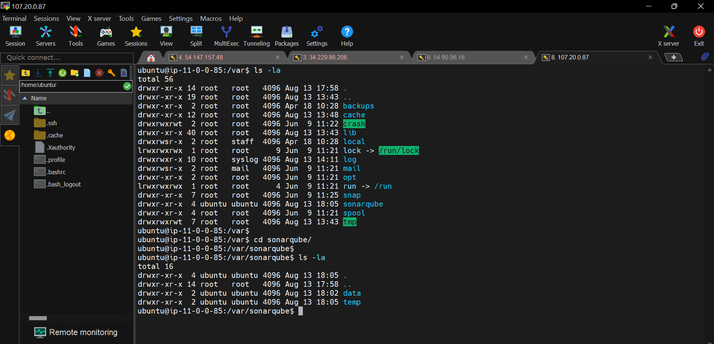

Now, owner ship is changed from root user to ubuntu usr.

Let’s restart the server and check.

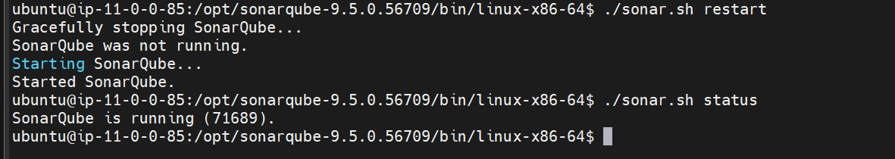

Now, go to browser and refresh

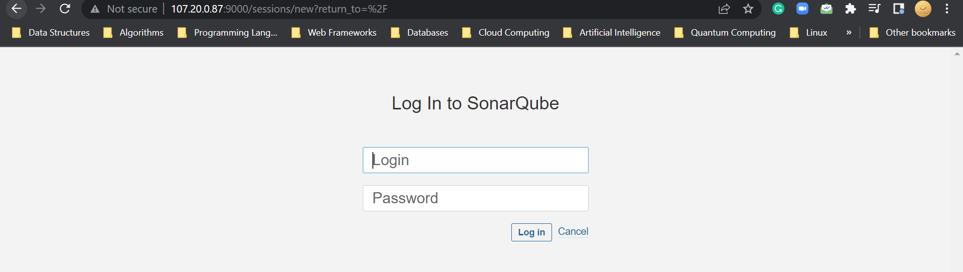

It’s loaded successfully.

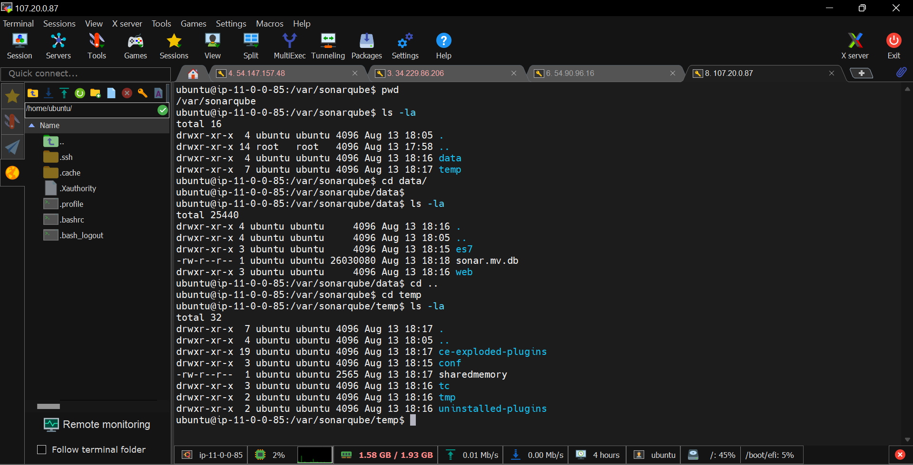

We can see that the SonarQube data is started storing in the given path directories.